**Helping your child to hear the sounds in words (phonological awareness)**

**A brief overview of phonological awareness**

For children to read and write, they must have an awareness of the sounds in language and an ability to manipulate these sounds. This is called phonological awareness.

Phonological awareness is achieved when we can:

Break language down into sentences

e.g. We had a lovely picnic on holiday. / We had sandwiches and crisps.

Sentences are broken down into words

e.g we / had /sandwiches /and / crisps

Words can be broken down into syllables

e.g. sand / wich / es

Syllables can be broken down into onset and rime

e.g. s / and

Children must to be able to hear the above and must also be able to:

• hear the initial sound in words

• recognise and create rhymes

Before children come to school we can help them by:

* chatting with them
* teaching them new words
* singing nursery rhymes
* singing other songs and rhymes
* singing action rhymes with our children (e.g. ‘Row, row, row the boat)
* playing simple word games like I Spy

Sometimes children need to carry on playing language/sound games after they have started school. Ideally, these games should not include your child reading and writing.

Below are some fun activities to support your child’s phonological awareness development at home.

**Menu of phonological awareness activities:**

|  |  |  |
| --- | --- | --- |
|  |  |  |
|  |  |  |
|  |  |  |

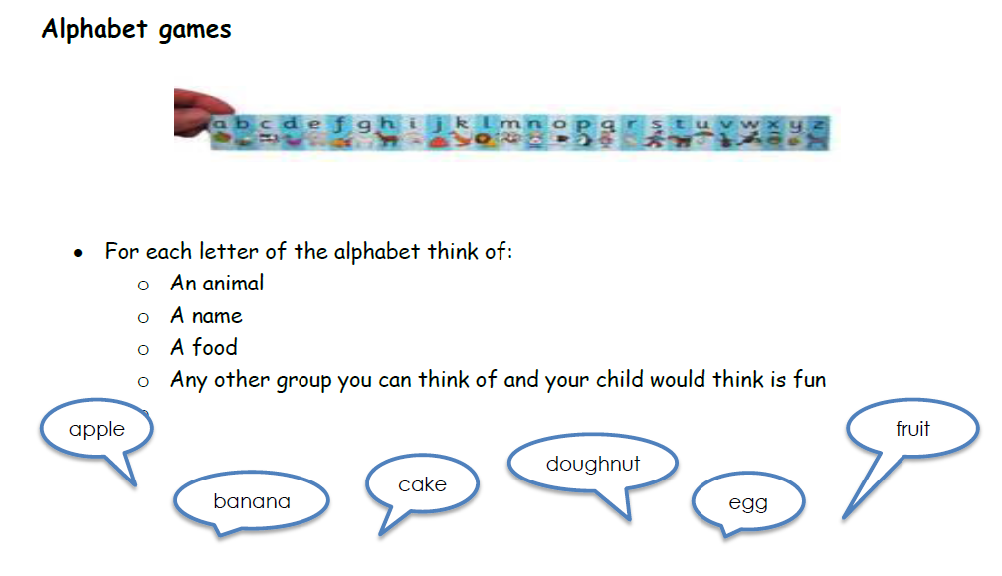

**Play the ‘feely bag’ rhyming game**

Find 6 pairs of objects from around the house with rhyming names. Put the objects in a bag. You pull an object out and then your child feels in the bag to find an object which has a name that rhymes with your object.

**Useful weblinks and resources:**

This list is by no means exhaustive. It is easy to find ideas online by searching ‘phonological awareness activities’ into a search engine.

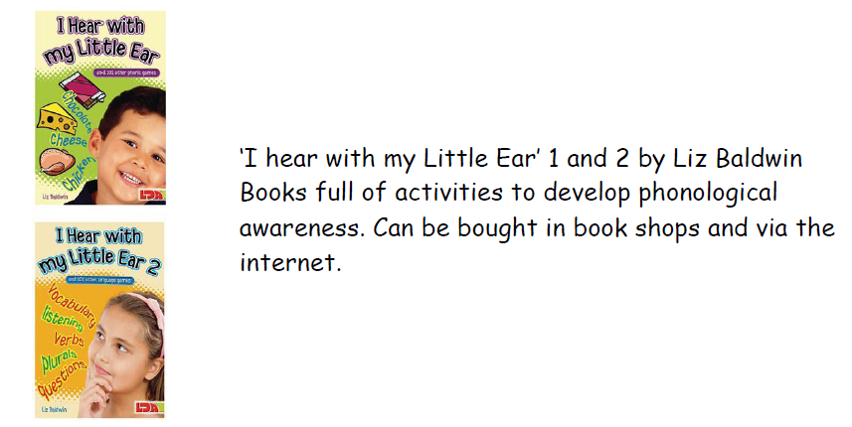

[**http://www.scholastic.com/parents/blogs/scholastic-parents-raise-reader/5-favorite-games-play-words**](http://www.scholastic.com/parents/blogs/scholastic-parents-raise-reader/5-favorite-games-play-words) **- here you can find some suggestions for fun word games that you can buy**

**Ideas of games to play:**

[**https://www.superduperinc.com/handouts/pdf/172%20Phonological%20Awareness.pdf**](https://www.superduperinc.com/handouts/pdf/172%20Phonological%20Awareness.pdf)

[**http://www.pdst.ie/sites/default/files/Phonological%20Awareness%20Infants.pdf**](http://www.pdst.ie/sites/default/files/Phonological%20Awareness%20Infants.pdf)

[**http://www.scholastic.com/parents/blogs/scholastic-parents-learning-toolkit/word-games-to-play-kids**](http://www.scholastic.com/parents/blogs/scholastic-parents-learning-toolkit/word-games-to-play-kids)