|  |  |  |
| --- | --- | --- |
| *1* | Ahoy | Hello |
| *3* | Cutlass | A curved sword |
| *4* | Booty | Stolen goods/treasure |
| *5* | Jolly Roger | Pirate flag (skull and crossbones) |
| *6* | Buccaneer | A pirate, originally one operating in the Caribbean. |
| *7* | Port | A town or city with a harbour |
| *8* | Harbour | A place on the coast where ships can stay sheltered from the open seas |
| *9* | Crow’s nest | A place on a pirate ship where pirates look out for land or other ships |
| *10* | Marooned | Being left alone somewhere. For pirates, this usually was on a desert island |
| *11* | Deserted | An empty place |
| *12* | Galleon | Large, multi-decked sailing ships |
| *13* | Starboard and Port | Different sides of a ship |

**Vocabulary**

**Famous pirates**

|  |  |  |  |  |  |
| --- | --- | --- | --- | --- | --- |
| William Kid | Captain Blackbeard | Anne Bonny  C:\Users\Twinkl\Desktop\bulkr\Captain Kidd buries his bible_4967448799_o.jpg | Calico Jack | Mary Read | Black Bart |
| 1645- 1701 | 1680-1718 | 1698- 1782 | 1682- 1720 | 1685- 1721 | 1682-1722 |
| Kidd was very unlucky as he was forced into piracy by his unruly ship crew whilst on duty.  Kidd was the only pirate known to have ever buried any treasure on Long Island, New York. | One of the most dreaded pirates who ever lived!  He terrorized the Atlantic Ocean and Caribbean sea for 2 years. | Women were considered bad luck to have on board a ship but that didn't stop Anne Bonny. She acted and dressed just like a male pirate and was excellent at fighting. | Calico Jack had this nickname because of what his shirts were made from! He was famous for wearing very fancy clothes and being very handsome. | Mary Read was friends with Anne Bonny. They worked together to capture ships in Jamacia. Mary grew up pretending to be a boy. | Black Bart’s real name was Bartholomew Roberts.  He came from Wales. He was religious and wouldn’t fight on a Sunday. |

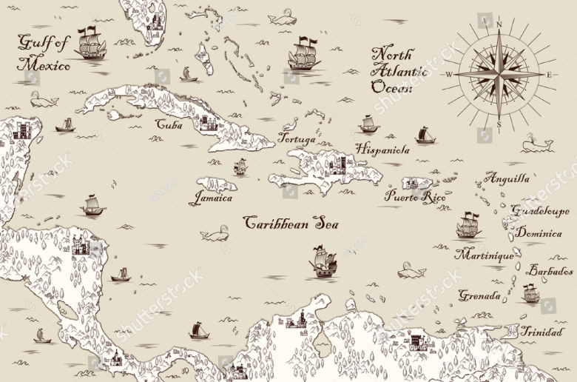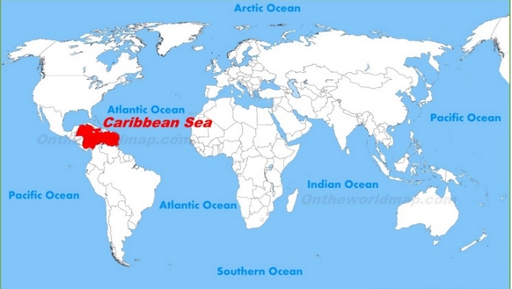

The “golden age” of piracy occurred in the [Caribbean](https://kids.britannica.com/students/article/Caribbean-Sea/273521) between about 1650 and 1730.

During this time more than 5000 pirates were said to be at sea. The Caribbean Sea was very popular with pirates because there were many small islands to hide.