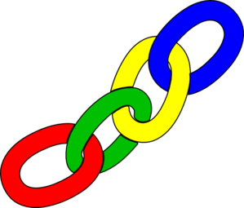**Linking**

* What do you know about…?
* Do you know another story…?
* Have you read a book with a similar theme?
* Do you know another character like…?
* What do we know about this place/point in time?
* What do we already know about how this author writes?
* Which things are already familiar to you? ( structure, layout, characters, language)
* How has the period affected the writer?

**Retrieval**

* What does that word mean?
* Can you think of another word that means the same?
* Where did the story take place?
* 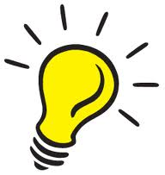What happened…?
* Read the part that tells me…
* What did he/she do?
* Where did…?
* Who are the main characters?
* Who did…?

**Predicting**

* What will happen next?
* What will he/she do?
* What will…do next?
* What will the author do next?
* How will he/she solve the problem?
* How will it change?
* What will he/she tell us about next time?
* What will the next page look like?

**Inferring**

* What makes you think that?
* Can you explain why…?
* What is your opinion?
* What does this tell you about…?
* Which word gives you that impression?
* What is the character like?
* How does he/she feel at the moment? What tells you?

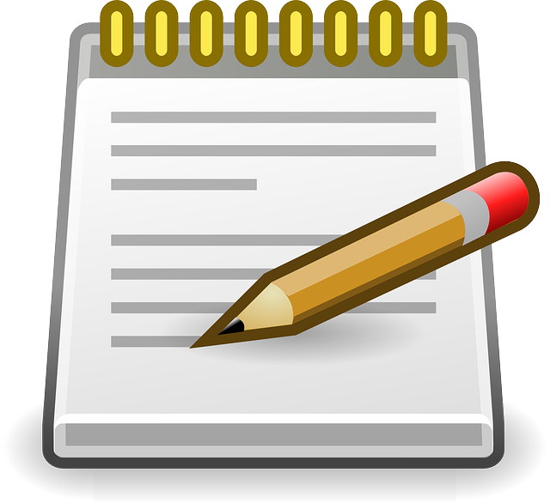**Summarising**

* What were the key points?
* Summarise the …
* What has happened so far?
* Describe the current situation.
* What did the chapter/section/page tell you?
* What is the main idea?

**Understanding the writers’ use of language**

* Why did the author use these words?
* How has the author used … to …?
* What effect has the author created?
* How has the author used words and sentences to …?
* What does the word … tell you about …?
* Why did the author choose this …?
* Why has the author written the sentence in this way?
* Which words and phrases tell you this?
* What do you notice about the sentences?

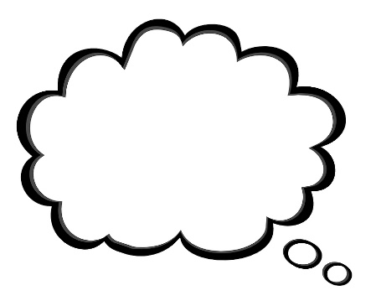**Imagining**

* What is he/she thinking?
* What is he/she feeling?
* What would if feel like there?
* How would you feel?
* What would you do?
* Describe the place
* Describe the character to me