At home ideas to help support learning
- Play I-spy using letters or colours e.g. I spy with my little eye something beginning with ‘a’ or I-spy with my little eye something the ‘colour green’
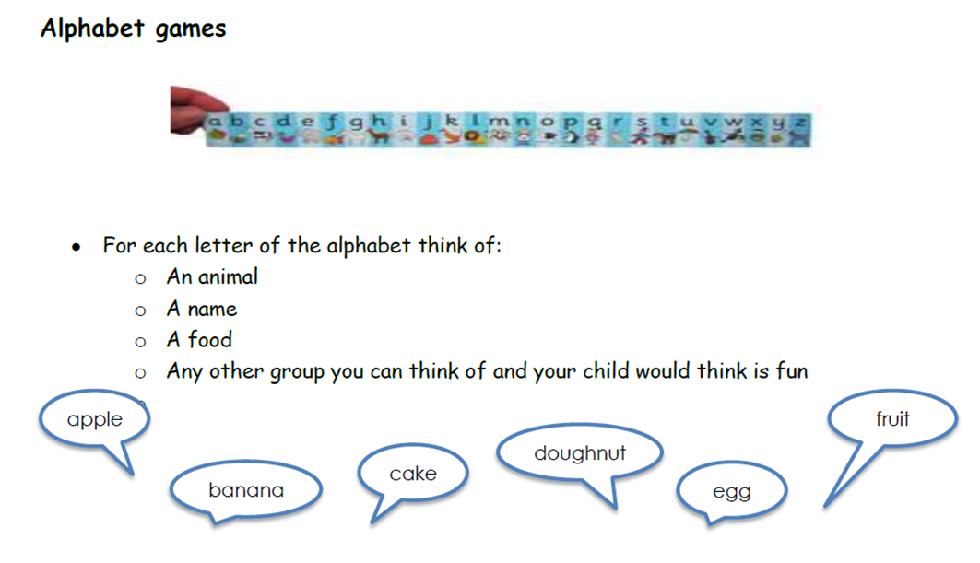
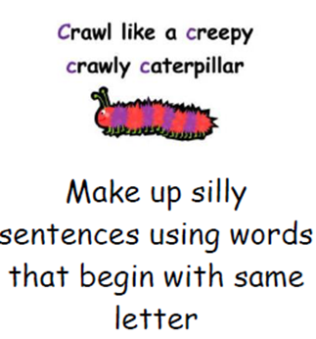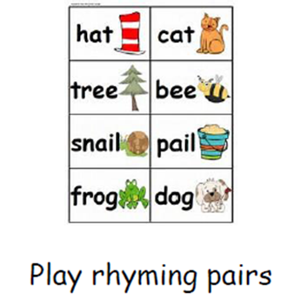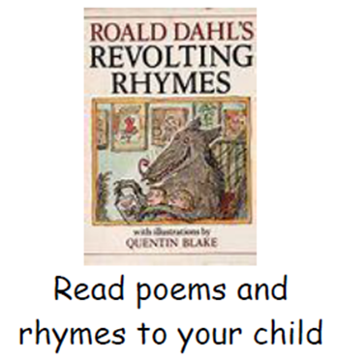

- Read a story to your child and talk about what they think will happen next and what is happening in each picture,

- Log onto ‘Phonics play’ by Googling it online and use the given Username (march20) and Password (home) to use the games for free. Start with Phase 1 and see how you go. https://www.phonicsplay.co.uk/

- Blow bubbles and count them as you go

- Learn songs and rhymes such as… 5 little monkeys jumping on the bed… Ten in a bed….. 5 current buns in a bakers shop….. 1, 2, 3, 4, 5 once I caught a fish alive…

- Race/ball games – discuss first, second, third. Count and add scores. Time the games using the stopwatch on a phone.

- Shape hunts – search for flat 2D and 3D shapes in the environment

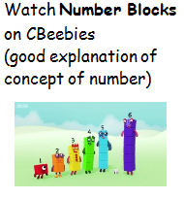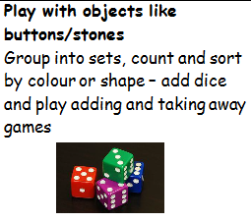
Use Lego
- Measure items around the house using Lego bricks talk about which items are the biggest/largest and which are the smallest. How do they know? How many more bricks long is the bigger item?
- Stack and make number towers
- Use to write simple number sentences
- Use to help number bonds e.g. a ‘4’ brick and ‘6’ brick to make 10

Number hunts
Hide numbers around the house to find, for a greater challenge the clues could be calculations and they have to find the answer e.g. 2 + 9 =
Drawing
Sit and draw together – how many shapes can they spot in their picture?

Play Dough
Make small balls/shapes out of play dough and count them. How many do I have if I take one away?
Throwing and catching
- Count how many times you can throw the ball to each other without it dropping
- Can you sing a rhyme together and throw the ball as you sing?
- Take it in turns to roll the ball – who can roll it the furthest?
- Can you use different parts of your body to roll the ball? Which parts were hardest and which were the easiest?

Colour by number – (you don’t have to have a shop bought colour by number book it’s easy to make your own!)
Take a normal colouring book and choose around 4 colours. Write four different numbers down the side of the page and add square of the colour you want to link to that number. Then write the numbers on the colouring picture to indicate what colour each section should be. Children to look for the numbers in the picture then look at the key you’ve created to choose the correct colour.
e.g. 1 =
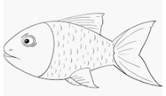
4 =
2
6 =
6
8 =
4
1
2

Menu of memory games:
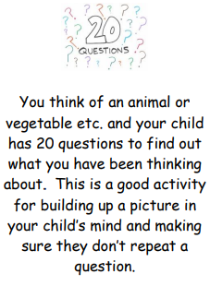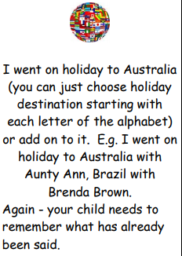
- Kim’s Game – place common things, such as pencil, key, fork, penny on a tray. Ask your child to look at them for e.g. 60 seconds. Cover the tray and ask your child to write down or say the items on the tray. You can also take away an item and ask what is missing.

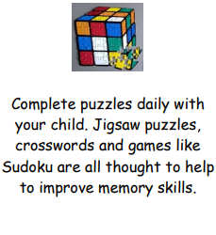
- Choose a simple spelling that your child needs to practise (can be their own name) Give your child the word and say the first letter. Your child says the second letter and you take it in turns until the word is completed.

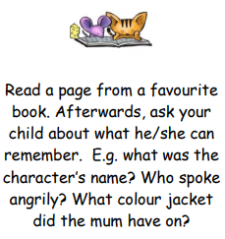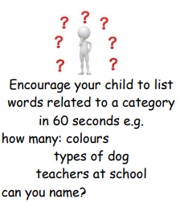

Ideas of games to play:
https://www.superduperinc.com/handouts/pdf/172%20Phonological%20Awareness.pdf
http://www.pdst.ie/sites/default/files/Phonological%20Awareness%20Infants.pdf
http://www.scholastic.com/parents/blogs/scholastic-parents-learning-toolkit/word-games-to-play-kids

Useful weblinks and resources:

http://www.bbc.co.uk/cbeebies/shows/numberblocks - Sing along and learn all about numbers
https://www.education.com/activity/math - A range of engaging maths activities to help your child to master key math skills.
http://www.oxfordowl.co.uk/maths-owl/maths - Oxford Owl includes a range of activities, top tips and eBooks to help your child with their maths at home.
http://www.maths4mumsanddads.co.uk/index.php - This website explains some of the milestones children make between the ages of 3 and 11 years old.

Keeping Active:
- Joe Wicks has kids workouts on Youtube. Hiit sessions for children (5 minute videos can be done in a small space)
- Kids workout – the Body Coach TV
- Go Noodle – Free to sign up (they do this in school so will be very familiar with this one)
- BBC Supermovers
- Cosmic Yoga on Youtube
- Healthy futures – http://eepurl.com/gVYzoD you can receive a weekly food and activity log plus daily exercise videos to keep children active!
- @GetSet4PE will be tweeting an active task each day that schools are closed for

