**How I will stay safe in school**

It is **VERY** important that I remember I can’t go too close to my friends and teachers and I can’t touch them.

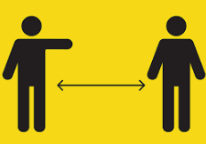

I will be excited to see them but **I MUST** keep a **big gap** between us so we are safe. I can let them know I am happy by:

* **Waving** at them,





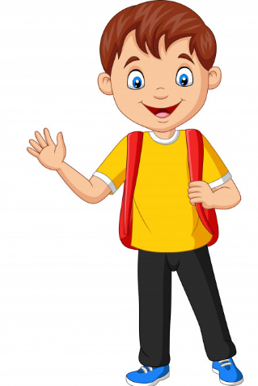

* **Smiling** at them
* **Talking** to them across the gap

It will be lovely to go back to school but I must make sure I **listen**



and **stay safe**!