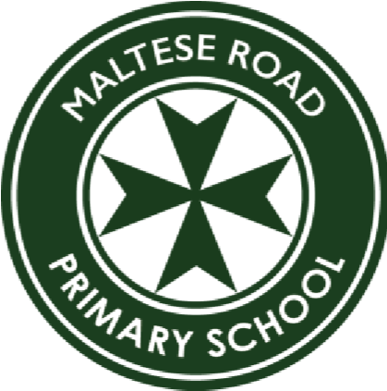
MALTESE ROAD PRIMARY SCHOOL
Maltese Road, Chelmsford, Essex CM1 2PA
Tel: 01245 357860
E-mail: admin@maltese.essex.sch.uk www.malteseroadprimary.com
Headteacher: Mrs Faye White

16th February 2024

Dear Parents/carers
I am writing to introduce you to our Poetry by Heart school competition. All children have been invited to learn and perform a short poem from our anthology or a poem of their choice. These shall initially be performed to their house teams on Wednesday 13th March, after which a vote will decide a performer from Reception, Key Stage 1 (Year 1 and Year 2), Lower Key Stage 2 (Year 3 and Year4) and Upper Key Stage 2 (Year 5 and Year 6) from each house.
The live finals will take place in the hall on Thursday 21th March, which is world poetry day. This is an invaluable experience for children to learn a poem for life, teaching them to enjoy, share, participate and express themselves through language.
When preparing a performance, we have encouraged the children to consider three important factors: voice, performance and accuracy.
Voice – is their voice loud and clear? Can we hear and understand every word? Are they changing the tone of their voice as appropriate to the poem?
Performance – can they bring the poem to life with movement and actions?
Accuracy – do they really know the poem inside out, can they recite every word confidently?
To access the suggested poems from school, please see your child’s class page, on the school website, under the icon Poetry by Heart. If you would rather have a print out of these poems, please speak to the class teacher.
I hope you will support your child in learning a poem for the competition. Thank you in advance.
Kind regards

Mrs Faye White
Headteacher

