 Maltese Road Primary School
NEWSLETTER Friday 17th October 2025

Dear Maltese Road Families

🌾 What a Wonderful Way to End the Week! 🌾
What a fantastic way to finish the week with our Harvest Festival celebration!
A huge thank you to all our parents, carers, and families for joining us and supporting the children. It was such a joy to see everyone together, celebrating the hard work and creativity of our pupils.
The children truly shone with their beautiful singing, expressive storytelling, and wonderful artwork. We were also so impressed by their interesting facts about harvest traditions and their thoughtful reflections on the importance of helping others through our Food Bank donations. Your generosity and encouragement mean so much, thank you!
It was lovely to see such a strong sense of community and gratitude throughout the morning. These are the moments that make school life so special.

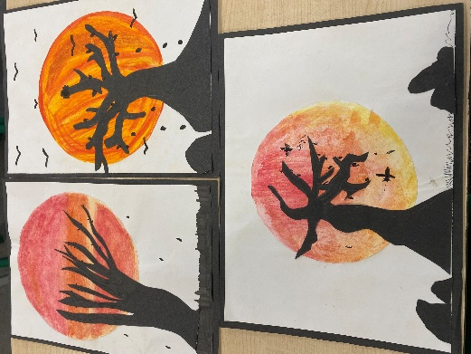

In other school news:
Our Autumn Term learning is in full swing — children are settling beautifully into routines and enjoying their new topics.
Hello Yellow Day 💛 – We had a wonderful time celebrating Hello Yellow Day, taking time to reflect on our own wellbeing and the importance of looking after our mental health. The children took part in a range of calming activities, including mindfulness moments, breathing exercises, and creative art sessions designed to help them feel calm, focused, and regulate their emotions. It was a lovely reminder that even small acts of kindness and self-care can make a big difference!

Inter-School Football match against Meadgate
⚽ Football Match Update – Well done to our Year 6 football team who played brilliantly against Meadgate this week, securing an impressive 4–2 victory! The team showed fantastic teamwork, determination, and great sportsmanship throughout the match. We’re so proud of their effort and enthusiasm – congratulations to everyone who took part!

This week a selection of Year 4 and Year 5 girls were lucky enough to attend a science day workshop at Chelmsford County High School for Girls. They had a fantastic day taking part in all sorts of different experiments and using the lab equipment.

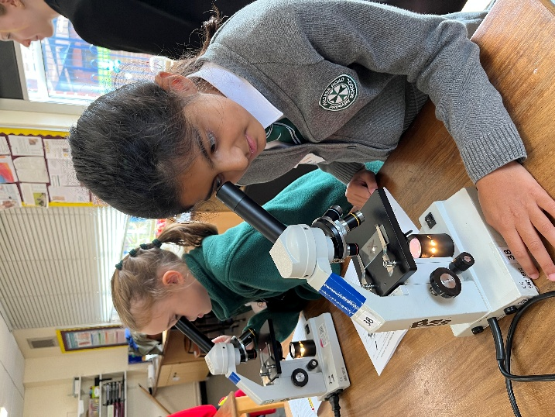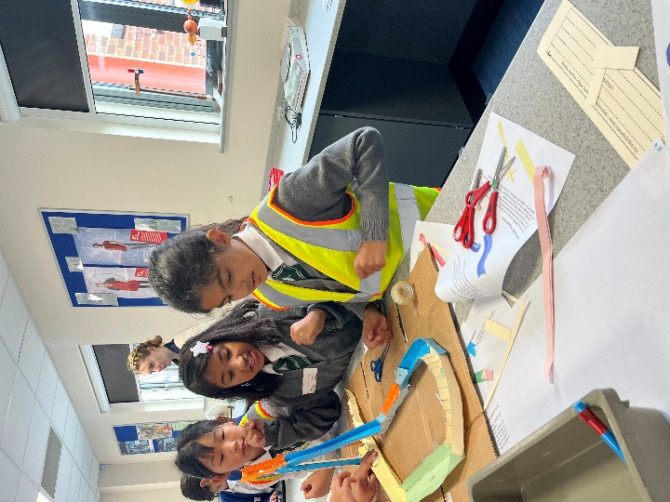

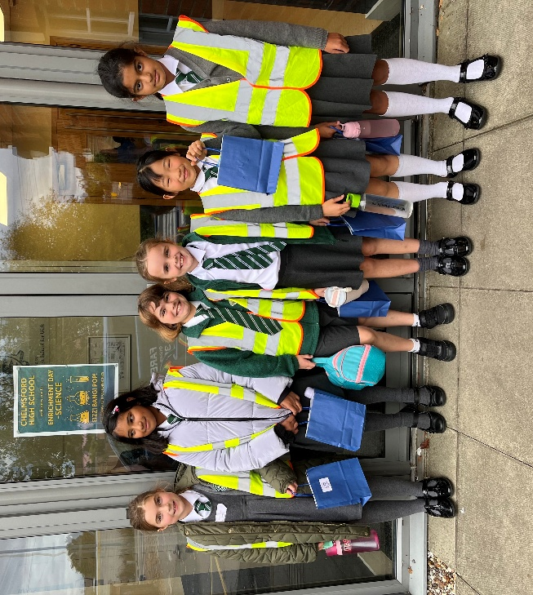


Next Monday, 20th October, our Year 6 councillors will be selling Poppies and merchandise on behalf of the Royal British Legion. For a minimum £1 donation, children will be able to purchase slap bands, key rings, pencils to name a few items.

- Safety is priority:
A couple of polite reminders for the school grounds before and after school.
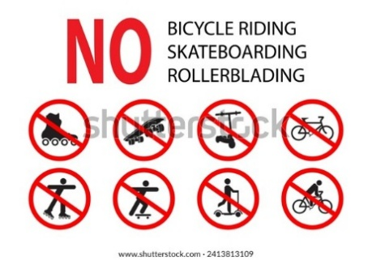
- Riding scooters and bikes is not allowed on school property. This is to prevent collisions and ensure the safety of students, parents, and staff.
Walking is required:
Students are expected to walk their bikes or scooters once they arrive at the school gate.
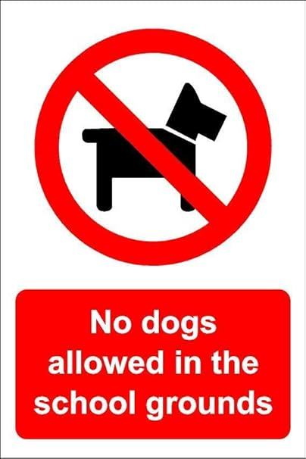
- No Dogs:
Busy school environments can be unpredictable, and even well-behaved dogs might react unexpectedly to crowds or other dogs, posing a risk of snapping or biting.
Health and allergies:
The presence of dogs can be a problem for students or staff who have allergies or phobias.
Fouling:
There is a risk of dog fouling on school fields and playgrounds, which is a health hazard.
Unpredictable behaviour:
The combination of noise, crowds, and children's unpredictable behaviour can stress dogs, potentially leading to fights or other issues.
What this means for dog owners
- Do not bring your dog onto the school grounds: This includes the playground, fields, and any area within the school fence, especially during drop-off and pick-up times.
- Do not leave dogs tied up: It is not permitted to leave your dog tied up at the school gates.

Children must not use the climbing frame or play equipment after school because staff supervision is limited, and the equipment may not be safe or suitable for use at that time. The school grounds are for supervised activities during school hours only, and a rule like this ensures all children are supervised at all times.
Reasons for this rule
- Limited supervision:
After a school day ends, supervision is focused on the designated collection points. The playground and its equipment, including the climbing frame, are not covered by this supervision.
- Safety:
A primary reason for this rule is to prevent accidents. Without a teacher or staff member watching, children could get hurt, and the risk of injury is higher when children are playing unsupervised on large equipment like a climbing frame.
- Equipment status:
The climbing frame may be closed for repair, making it unsafe for any use.

 Good afternoon,
Thank you all so much for your fantastic support with the book fair this term. We raised £208, bringing our total to £643.77 to spend on books for the school!!

Reminders 
- FOM Pumpkin Carving Contest
- FOM Non-Uniform Day – Friday 24th October
- FOM Halloween Trail – Friday 24th October after school
- Choir Club Visit to Okeley Care Home on Wednesday 22nd October
- Year 2 & 4 Layer Marney – Please make payment via Arbor and return forms asap
- Year 5 Duxford – Please make payment via Arbor and return forms asap
- PGL Deposit – Please make deposit payment via Arbor to secure your child’s place

Safeguarding Alert: Children’s Spy Books by the author Andy Cope
We are bringing to your attention a recent safeguarding issue affecting some popular children’s books by Andrew Cope, including the Spy Dogs, Spy Cats, and Spy Pups series.

Some editions of these books include a printed web address at the back. This link used to go to the author’s website, but the domain is no longer under his control. It has since been taken over by another party and now leads to inappropriate adult content.

The publisher, Puffin, has paused sales and distribution of the books and is working with schools, libraries, and retailers to remove copies from circulation. They have stressed that the website has no connection to the author or publisher.

What this means for you:
If your child has any Spy Dog, Spy Cat or Spy Pups books at home, please check the back for website links and make sure they do not try to visit the site.

It is safe for children to continue reading the stories themselves — the concern is only with the outdated link.

We recommend talking with your child about the importance of not following web addresses in books without checking with an adult first.

These books are mainly aimed at 9-13 year olds, but have been in publication for more than ten years.

Letters Sent Home
8th October | Whole School | Aladdin Panto Letters
17th October | Years 1-6 | Club Letters

Teacher Club – Choir

Club | Year Groups | Day | Pick up time
Choir | 3 – 6 | Thursday | 4:00pm

dates for your Diaries: 

Date
- 22nd October | - FOM Pumpkin Carving Contest
- 24th October | - FOM Non-Uniform Day  - FOM Halloween Trail – After School
- 27th – 31st October | - Half Term
- 6th November | - Year 2 & Year 4 Trip to Layer Marney Towers
- 10th November | - Year 4 Times Tables Talk – Yr 4 Parents Invited – 3:15pm In the Classroom
- 11th November | - Year 5 Trip to Duxford Imperial War Museum
- 12th November | - Year 6 Residential Meeting in the Year 6 classroom – 3:15pm
- 21st November | - FOM Disco – Reception Class & Yrs 1 - 3
- 3rd December | - Reception Class Nativity at the Church – Parents Invited – 9:15am  - Parents Evening – 3pm – 6pm – Details to Follow
- 4th December | - Parents Evening – 3pm – 6pm – Details to Follow
- 5th December | - Key Stage 2 Panto Workshop
- 8th December | - Year 1 & 2 Production to Parents – 9:15am
- 9th December | - Aladdin Panto – Chelmsford Civic Theatre
- 10th December | - Christmas Dinner Day
- 11th December | - Year 1 & 2 Production to Parents – 1:30pm
- 17th December | - Key Stage 2 Carol Concert at the Church – Parents Invited – 9:00am
- 19th December | - Last day of Autumn Term
- 22nd December – 2nd January 2026 | - Christmas Holidays
- 5th January 2026 | - First Day of Spring Term
- 12th January | - Goodleigh Dental Practice Parent Talk – 2:30pm – Details to Follow
- 26th January | - Goodleigh Dental Practice – Reception Class & Year 3 – Details to Follow
- 16th – 20th February | - February Half Term
- 16th March | - Goodleigh Dental – Flip the Lip, Reception Class & Year 3 – Details to Follow
- 27th March | - Last Day of Spring Term
- 30th March – 10th April | - Easter Holidays
- 13th April | - First Day of Summer Term












2025-2026 Term Dates

Date
- 1st September | - Non Pupil Day
- 2nd September | - Non Pupil Day
- 3rd September | - First Day of Autumn Term
- 3rd October | - Non Pupil Day
- 27th – 31st October | - October Half Term
- 19th December | - Last Day of Autumn Term
- 22nd December – 2nd January 2026 | - Christmas Holidays
- 5th January 2026 | - First Day of Spring Term
- 16th – 20th February | - February Half Term
- 27th March | - Last Day of Spring Term
- 30th March – 10th April | - Easter Holidays
- 13th April | - First Day of Summer Term
- 4th May | - May Day Bank Holiday
- 25th May – 29th May | - May Half Term
- 1st June | - Non Pupil Day
- 17th July | - Last Day of Summer Term
- 20th July | - Non Pupil Day

Healthy Snack - 
Most children require a snack at morning break to keep them going through the day. We encourage children to bring in healthy snacks.
Many of these will help contribute to their 5 daily portions of fruit and vegetables, keep them alert and help them concentrate.
Children in EYFS and KS1 have a daily snack of fruit or veg provided for free by the government, so additional snacks for these ages may not be required.
If you are intending to send in healthy snacks with your child please limit them to the list below.
Vegetables/ vegetable sticks – such as celery, cucumber, peppers or carrot.
A piece of cheese (cheddar cheese or Babybel).
A piece of fresh or dried fruit – pineapple, mango, kiwi, plain raisins, apricots, blueberries, banana slices.
breads are also good snacks Bread sticks, plain pretzels, banana bread, malt loaf, oat/rice cakes and small pitta.
We are aiming for a common-sense approach, with the key being to keep it healthy and no chocolate, sweets or crisps during breaktime.


We are a nut aware school; we have children and adults with nut allergies, which could be very dangerous for them to be in contact. Please ensure that you check ingredients of all foods sent into school, even items you buy regularly, as there can be changes, to ensure there are no issues.

FOM news
We’re delighted to share with you some upcoming dates for the diary!
Wednesday 22nd October | Pumpkin carving contest
Friday 24th October | - Non-uniform day in exchange for a donation to FOM  - Halloween Trail after school (All years - parents / carers to accompany children)
October Half Term | Half term Challenge: Our school is turning 10, and we’re celebrating with a fun “Power of 10” Challenge! Choose a 10-themed activity, get sponsored, and help raise £10 each to support our school!
Friday 21st November | Disco (Reception and Years 1-3)
Thursday 27th November | Wreath Making (adults evening event)

Thank you to everyone who attended the FOM AGM on 7th October.
We’re pleased to share details of the committee for 25/26 and a copy of the Chair’s report from last year.
Thank you to everyone for your continued support and we look forward to lots more fun and fundraising this year!
Don’t forget to give us a follow - plus if you have any ideas that you’d like to see from us or want to get more involved, do get in touch!

Any questions, please email friendsofmaltese@gmail.com
Don’t forget to follow us on social media:



