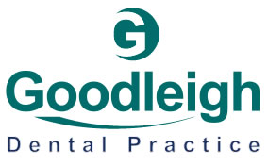

Goodleigh Dental Practice
41 Broomfield Road, Chelsmsford, Essex, CM1 1SY
01245 257 181

Dear Parent/Carer,
We are delighted to let you know that your school has been allocated to take part in a three-year NHS and Dental Commissioner (ICB) pilot scheme, which is now in its second year. As part of this project, Goodleigh Dental Practice has been working with local schools to deliver education sessions and dental screenings for Reception and Year 3 classes.
Alongside this, we are also hosting parent workshops—and this year we would like to extend the invitation to all parents across the school, not just Reception and Year 3.
These sessions are a fantastic opportunity to gain practical advice on supporting your child’s oral health at home. Between us (Ella and Clarissa), we have over 10 years of clinical dental nursing experience, as well as specialist qualifications as Extended Duties Dental Nurses. This means we can share the best quality oral hygiene advice, tips, and tricks to make toothbrushing easier and more effective—something we know can often be a challenge.
At the workshops, we’ll also provide:
- Practical demonstrations and guidance
- Free resources and goodies to take home
- The chance to ask questions and get advice tailored to your child’s needs
This is also a great opportunity for Reception and Year 3 parents to meet us ahead of the interactive sessions and consent-based dental screenings that will take place during the school year.
We would love to see you there and hope you can join us.
Date of visit: 12/01/2026 at 2:30
Thank you for your support in helping us give children the best start in their oral health journey.
Yours sincerely,
Ella Morris & Clarissa Royle
Extended Duties Dental Nurses
Goodleigh Dental Practice


