 Maltese Road Primary School
NEWSLETTER Friday 13th February 2026

Dear Maltese Road Families

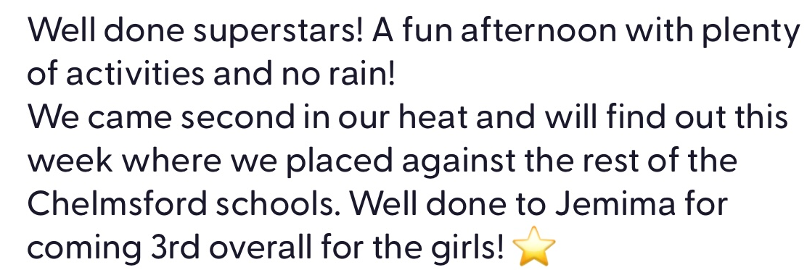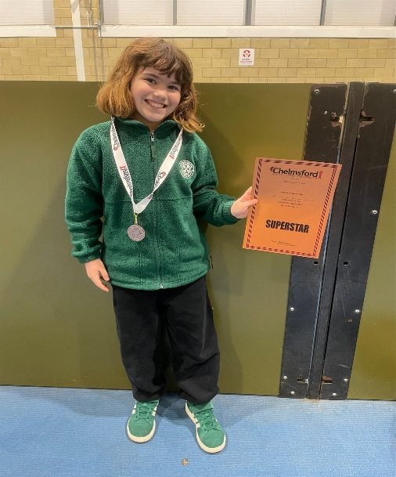

Reception & Year 5 Road Safety
This week, our EYFS children enjoyed a very special road safety session, and we were delighted to welcome their grown-ups to join us! Together, they learned all about how to stay safe near roads by remembering the important steps: Stop, Look, Listen and Think. The children practised stopping at the kerb, looking carefully both ways, listening for any traffic, and thinking about whether it was safe to cross. It was wonderful to see everyone working together, asking questions and sharing ideas about how to keep safe when out and about. Thank you to all the families who joined us and helped make this session such a valuable learning experience!

Year 5 learned all about road safety, to support them when they are allowed to walk home alone in the summer term. They put their understanding of road safety into practise with a walk up and down Maltese Road. The lady who delivered the road safety session was very impressed with the children's understanding and demonstrations of road safety.
 Year 4 Greek Food Tasting - As part of our Ancient Greece topic, Year 4 will be learning about Greek culture and traditions. To help bring this learning to life, we are excited to be holding a Greek Wow Experience, with a food tasting afternoon on Monday 23rd February.
During the afternoon, the children will have the chance to try a selection of traditional Greek foods, including feta cheese, olives, tzatziki, pitta bread, hummus, breadsticks, dolmades, figs, pomegranate seeds, tomatoes, red onion, anchovies and baklava. This will be a fun way for the children to explore Greek culture through food. Children will not be expected to try anything they do not want to.
As this is a Wow experience we are asking for a £1 donation to help cover the cost. Payments can be made on Arbor, under Trips.
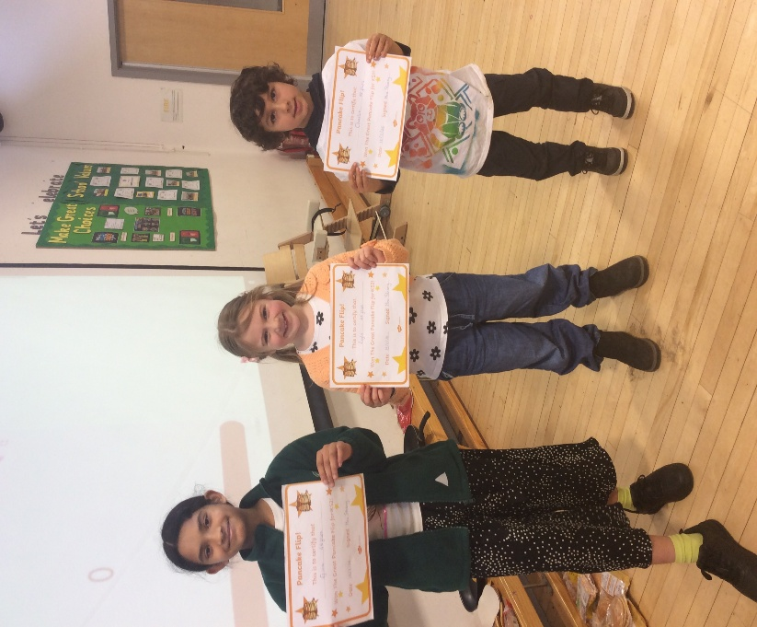
Congratulations to the following children for being Champion Pancake Flippers! The whole school had a fantastic day competing in the Great Maltese Pancake Flip! KS1 had 30 seconds to see how many 'jumps' the pancake could do and KS2 had 45 seconds to see how many complete flips they could do.
KS1: Charlie (72 flips)
LKS2: Layla C (46 flips)
UKS2: Efina (46 flips)
Congratulations!


We were very lucky to have a visit from Parkrun in Chelmsford, who came to talk to the children about the fantastic opportunity to take part in Chelmsford Parkrun.
It is a great way to encourage everyone to get involved, stay active and have fun.
Below is the link for more information and how to register!
https://www.parkrun.org.uk/register/

 After half term on Monday 23rd and Tuesday 24th February straight after school until 3:30pm children will have the opportunity to purchase books from the book fair. As with previous years, this will be held outside the Year 6 classroom under the canopy. This year, instead of a QR code to make payment, we will have a card machine. This will enable you to pay via Apple Pay, Google Pay, debit or credit card.

Sublime Science
On Thursday 12th March, Sublime Science will be coming into school to carry out a range of fun, hands-on and educational science workshops with each class. This is a wonderful and exciting opportunity for the children and one not to be missed!

We are asking for a contribution of £4 per child, to be paid online via Arbor under Trips. Please make payment by Wednesday 4th March 2026.

We wish you all a great half term and look forward to see the children back to school on Monday 23rd February.

Kind regards
Mrs White

Dates for your Diaries: 

Date
- 16th – 20th February | - February Half Term
- 23rd February | - Year 4 Greek Food Tasting  - Book Fair – Under the Year 6 Canopy Straight After School
- 24th February | - Book Fair – Under the Year 6 Canopy Straight After School
- 2nd March | - Whole School Dance Workshop
- 4th March | - Lockdown Practice
- 5th March | - World Book Day – Dress Up as Your Favourite Book Character
- 5th March | - FOM Wonka Bars – Details to Follow
- 12th March | - Sublime Science
- 13th March | - FOM Mother’s Day Daffodil Sale – After School outside the Hive
- 16th March | - Goodleigh Dental – Flip the Lip, Reception Class & Year 3 – Details to Follow
- 18th March | - Parents Evening – 15:30pm – 18:30pm
- 19th March | - Parents Evening – 15:30pm – 18:30pm
- 24th March | - Year 3 and Year 4 Performance – Parents Invited – 1:45pm – 2:45pm
- 25th March | - Year 3 and Year 4 Performance – Parents Invited – 9:15am – 10:15am
- 27th March | - Last Day of Spring Term
- 30th March – 10th April | - Easter Holidays
- 13th April | - First Day of Summer Term
- 17th April | - Year 1 Trip to Mountfitchet Castle
- 20th April | - Year 6 Visit to Chelmsford Theatre – Details to Follow
- 4th May | - May Bank Holiday
- 19th May | - Class Photos – Wear full school uniform
- 25th – 29th May | - May Half Term
- 1st June | - Non Pupil Day
- 8th – 10th June | - Year 6 Residential to PGL Overstrand Hall
- 19th June | - Sports Day
- 1st July | - Year 2 Mini Games at CSAC – Details to Follow
- 17th July | - Last Day of Summer Term
- 20th July | - Non Pupil Day
- 21st July | - First Day of Summer Holidays












2025-2026 Term Dates

Date
- 5th January 2026 | - First Day of Spring Term
- 16th – 20th February | - February Half Term
- 27th March | - Last Day of Spring Term
- 30th March – 10th April | - Easter Holidays
- 13th April | - First Day of Summer Term
- 4th May | - May Day Bank Holiday
- 25th May – 29th May | - May Half Term
- 1st June | - Non Pupil Day
- 17th July | - Last Day of Summer Term
- 20th July | - Non Pupil Day

2026-2027 Term Dates

Date
- 1st September 2026 | - Non Pupil Day
- 2nd September | - First Day of Autumn Term
- 2nd October | - Non Pupil Day
- 26th – 30th October | - October Half Term
- 17th December | - Last Day of Autumn Term
- 18th December | - Non Pupil Day
- 21st December – 1st January 2027 | - Christmas Holidays
- 4th January 2027 | - First Day of Spring Term
- 15th – 19th February | - February Half Term
- 25th March | - Last Day of Spring Term
- 26th March – 9th April | - Easter Holidays
- 12th April | - First Day of Summer Term
- 3rd May | - May Day Bank Holiday
- 31st May – 4th June | - May Half Term
- 7th June | - Non Pupil Day
- 20th July | - Last Day of Summer Term
- 21st July | - Non Pupil Day

 SEND News

Wilderness Foundation will be running our Neurodiversity Outdoor Camp on Friday 20th February, from 10am-3pm for young people age between 9-14 at £80 per participant per day.

The Neurodiversity Outdoor Camp is for young people experiencing challenges with mental health, behaviour and neurodiversity needs. Many young people can present with all these challenges together and we are increasingly aware that we need to support those with neurodiversity in a more dedicated and focused way. We have traditionally organised holiday camps and, recognising increasing needs for families and young people, we are running a specialist camp for those with neurodivergent needs.

The camp aims to develop personal skills, resilience, communication, social skills and a lot more. We cook on an open fire, are creative, adventurous and accepting. A range of outdoor activities that may include one of the following, cooking, art, bushcraft, nature walks, and crafts. We will also encourage positive social engagement and group skills, using a strength-based approach which helps participants become more aware of what they do well.

It will be a small group with not more than 8 participants and advance bookings are required.

For more information and booking form, please visit https://wildernessfoundation.org.uk/neurodiversity-holiday-camps/


How SPACE can support you?
How to access advice, guidance and resources for parents of children and young people with SEND.
Our team of Peer Educators are all parents and carers. They all have lived experience of supporting children and young people with special educational needs and disabilities (SEND). They understand the journey and are here to help you navigate it, wherever you are and whatever stage you're at.
We offer a range of accessible, flexible support options.
One-to-one support
Need to talk something through? Request a call from one of our experienced Peer Educators. They’ll get in touch to arrange a time that works for you.
Find out how to book a one-to-one session with a Peer Educator.
Online group sessions
Join regular online sessions covering a variety of topics. Connect with other parents and carers, share experiences, and hear practical advice from our Peer Educators.
Find out how to apply to join an online session.
School and community events
Meet our Peer Educators at local coffee mornings, school events, early years settings, and Local Offer SEND Roadshows. These informal gatherings are a great way to access support and build connections.
Find out about upcoming community events.

Our website
Explore a wide range of resources, tips, and information, all co-produced with parents and carers of children with SEND. Everything here is grounded in real-life experience and designed to help you support your child or young person.

In our Advice on SEND section, you can find detailed information on these topics:
- Understand and support your child's needs
- Daily routines
- Family life and relationships
- Education and school engagement
- Growing independence and future planning

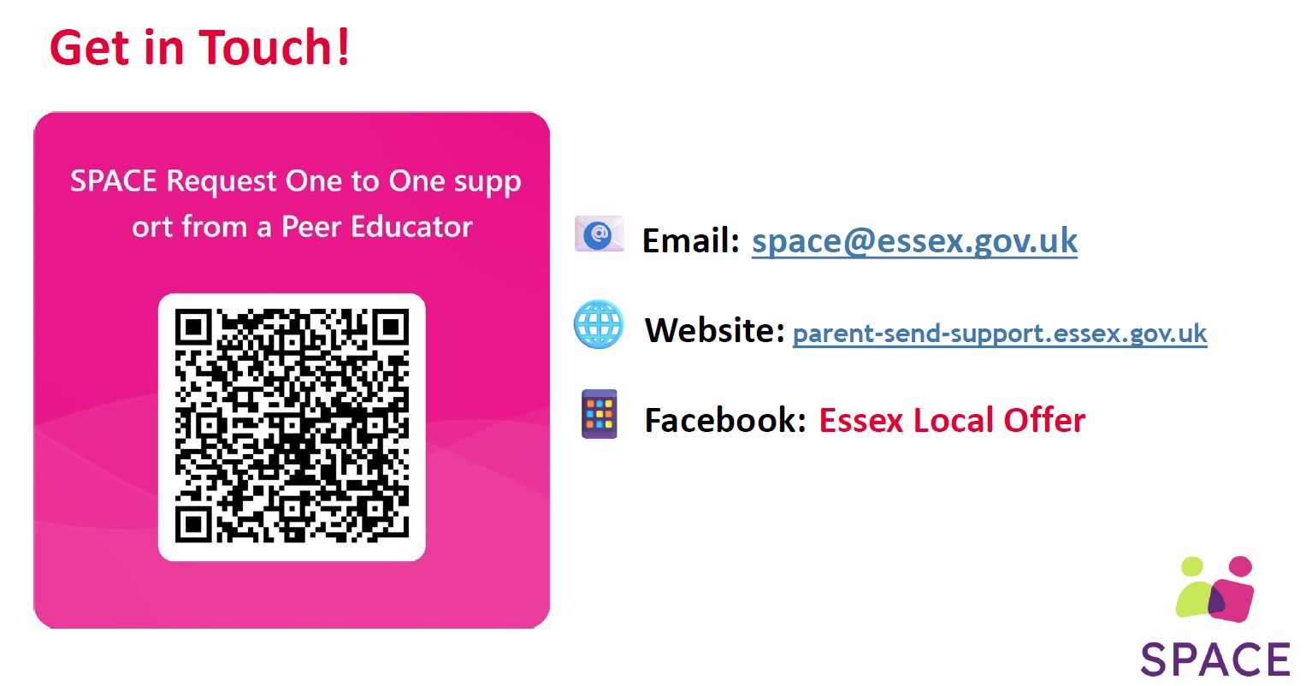



Local Community News & Activities

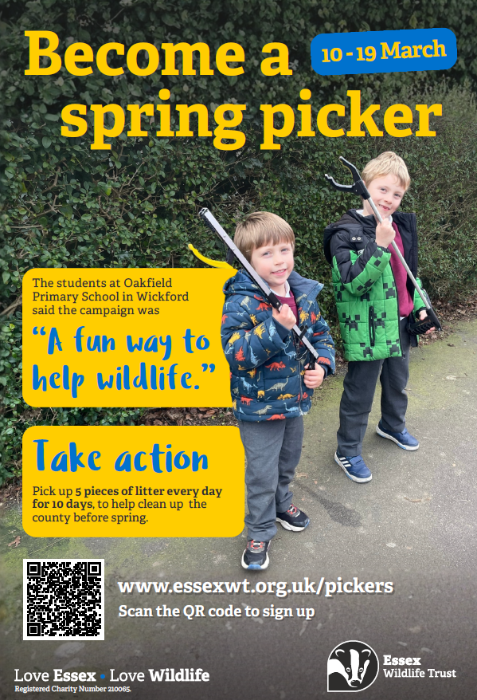



Church & Community Half-Term Activities:

- Chelmsford Cathedral (Feb 19): Storytelling Programme with Mike Dodsworth (11:30 am - 1:30 pm). Includes crafts, Lego, and a reading corner. Free, but booking is required.

- Christ Church (Feb 18): Free family event with messy play, singing, and food, 2 pm - 4 pm.

- Christ Church (Feb 16): K-Pop Demon Hunters Workshop (Reception – Year 6) from 9 am–3 pm.

- Chelmsford Indoor Market (Feb 23): Free bead-making workshops (10am–12pm & 1–3pm).

